Deepam Mahesh Patel

Symphony Emporium

Product Search Functionality

Feature Product Slider

Full Home Page with Logo

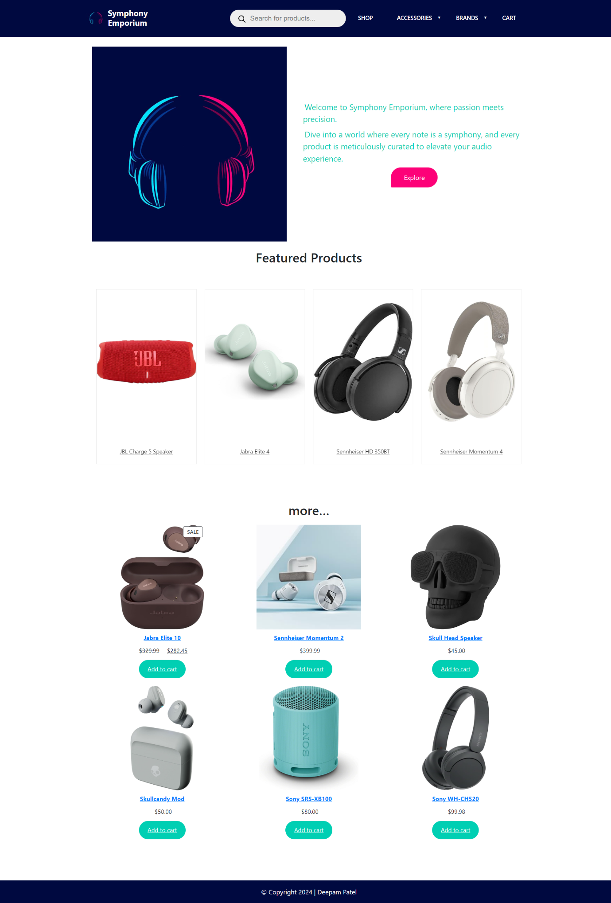

Shop Page

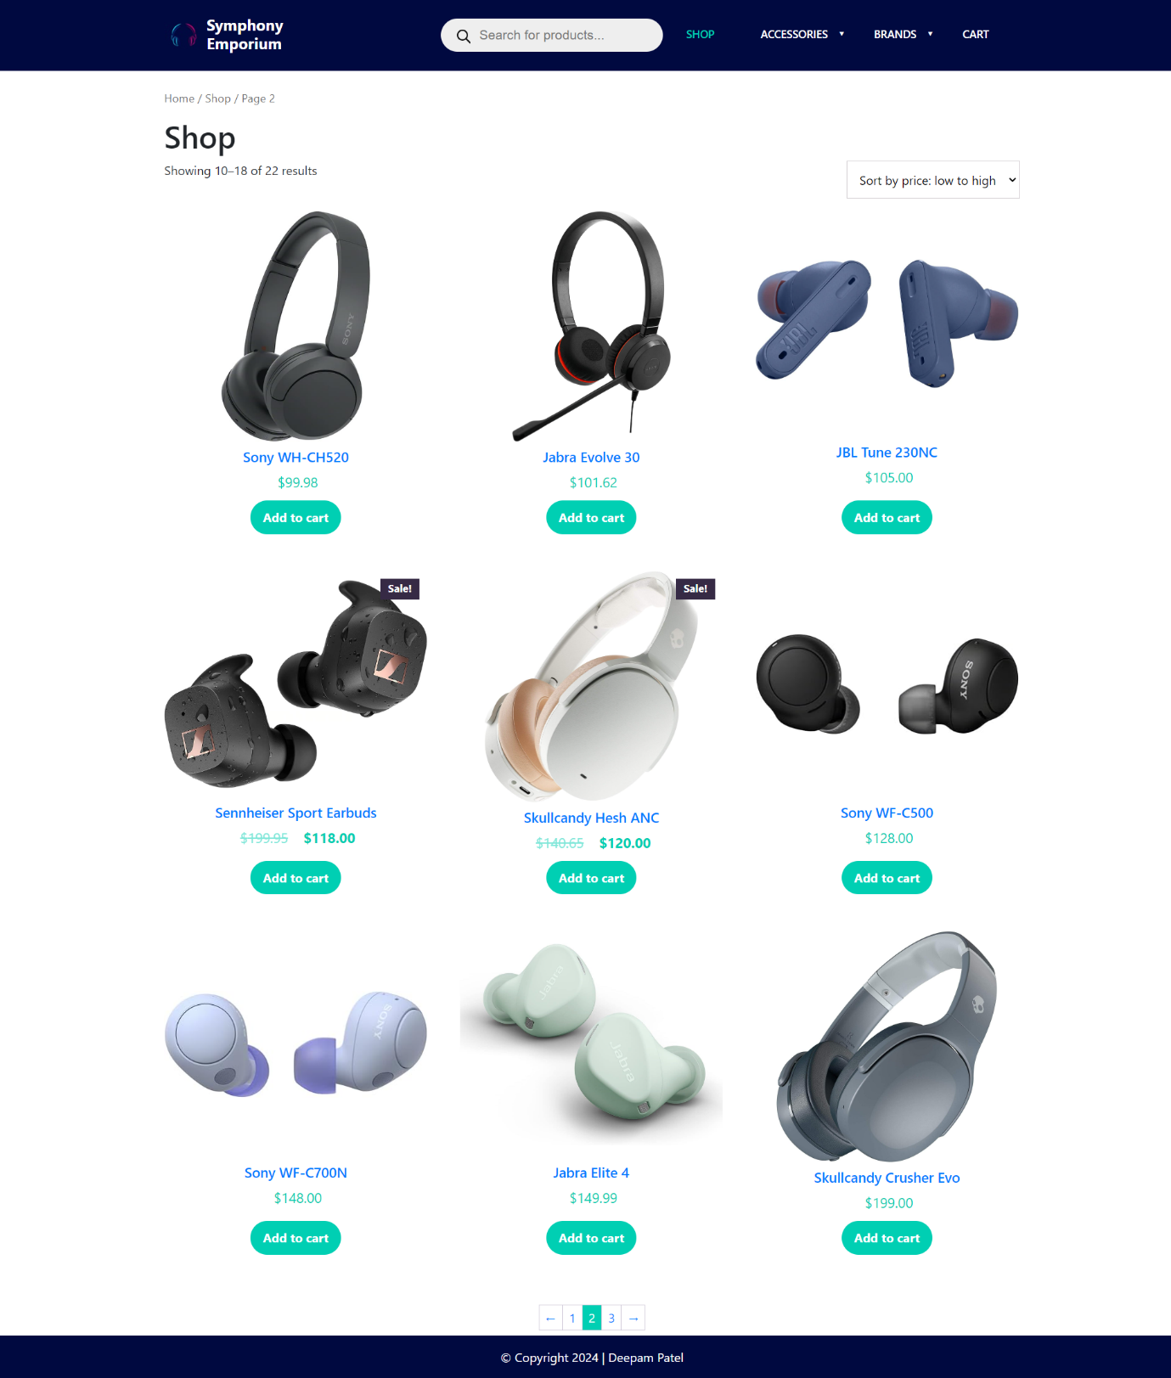

Category View

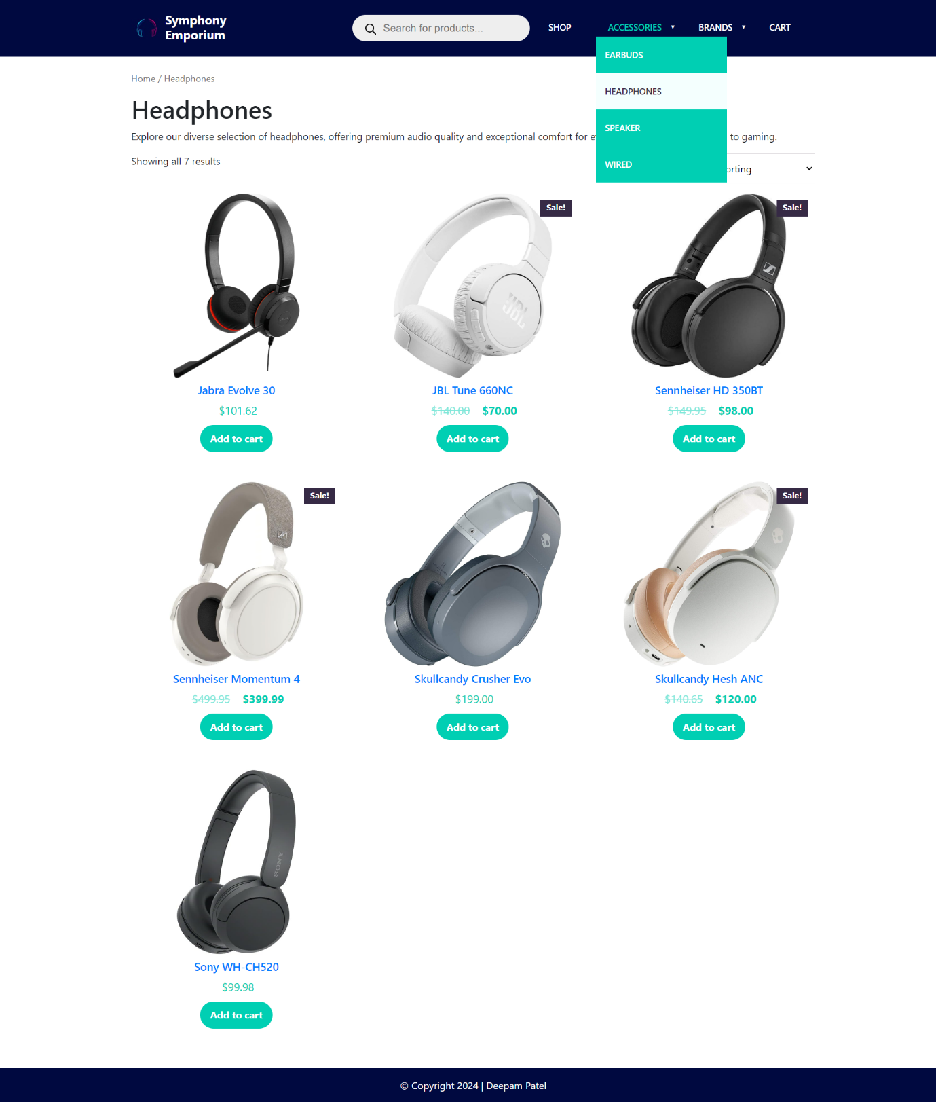

Tag View

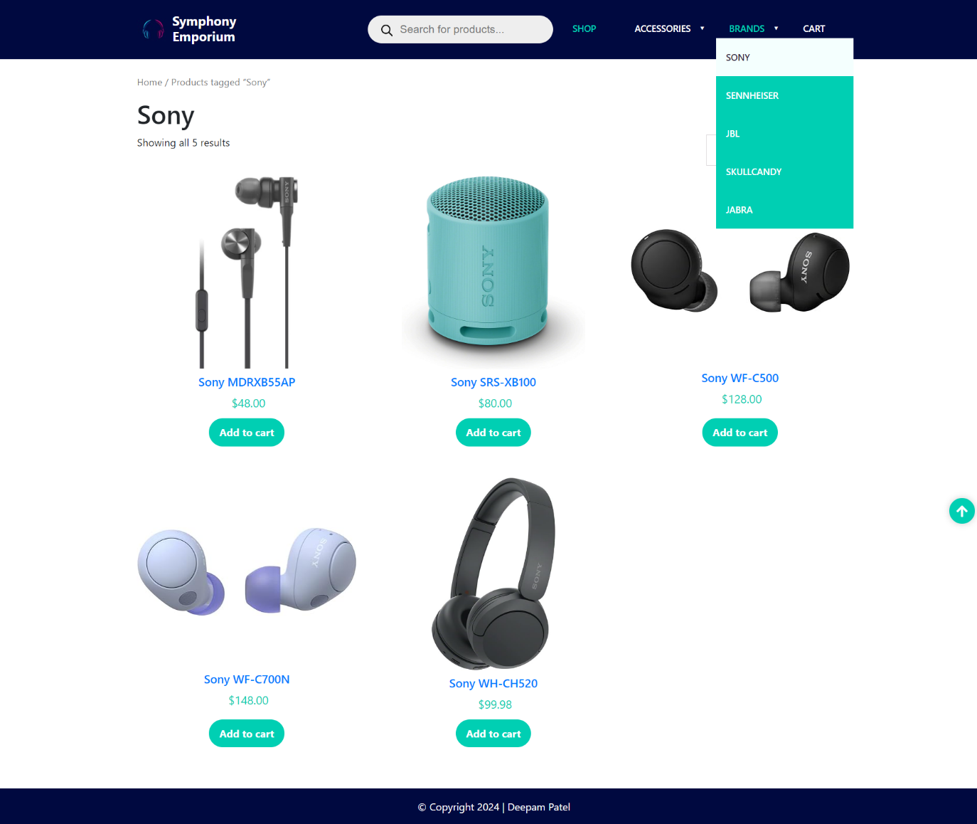

Sorting

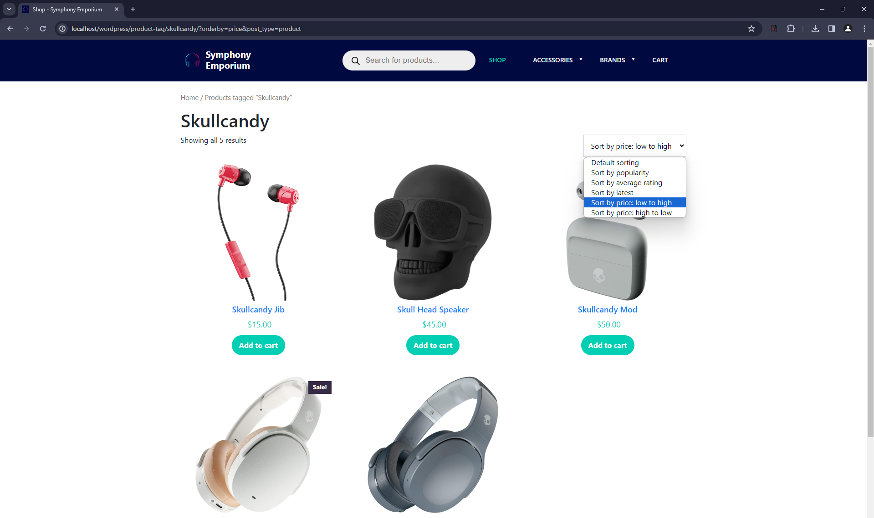

Product

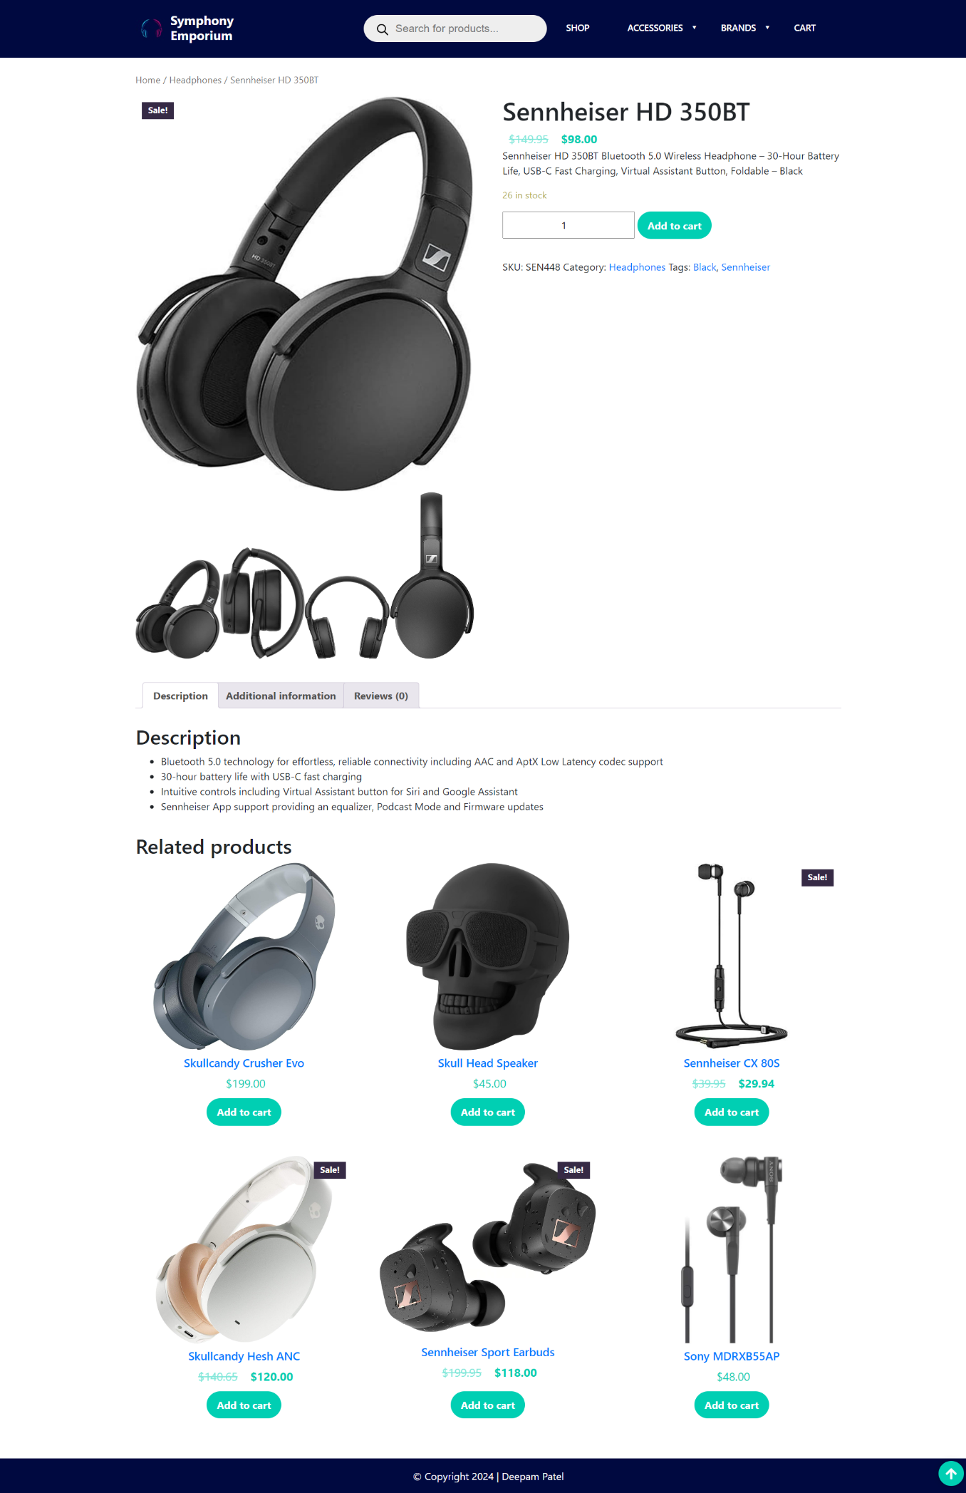

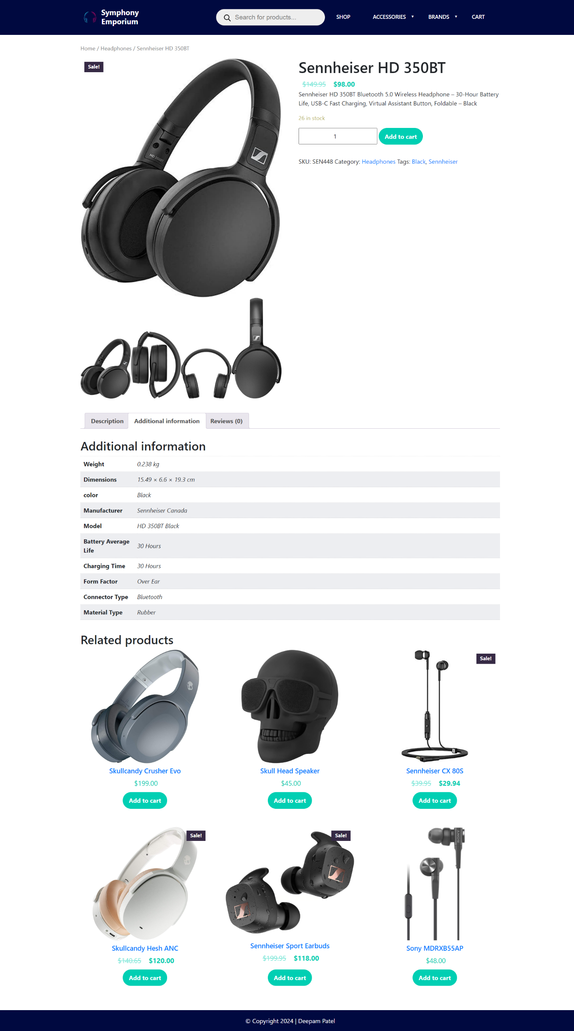

Empty Cart

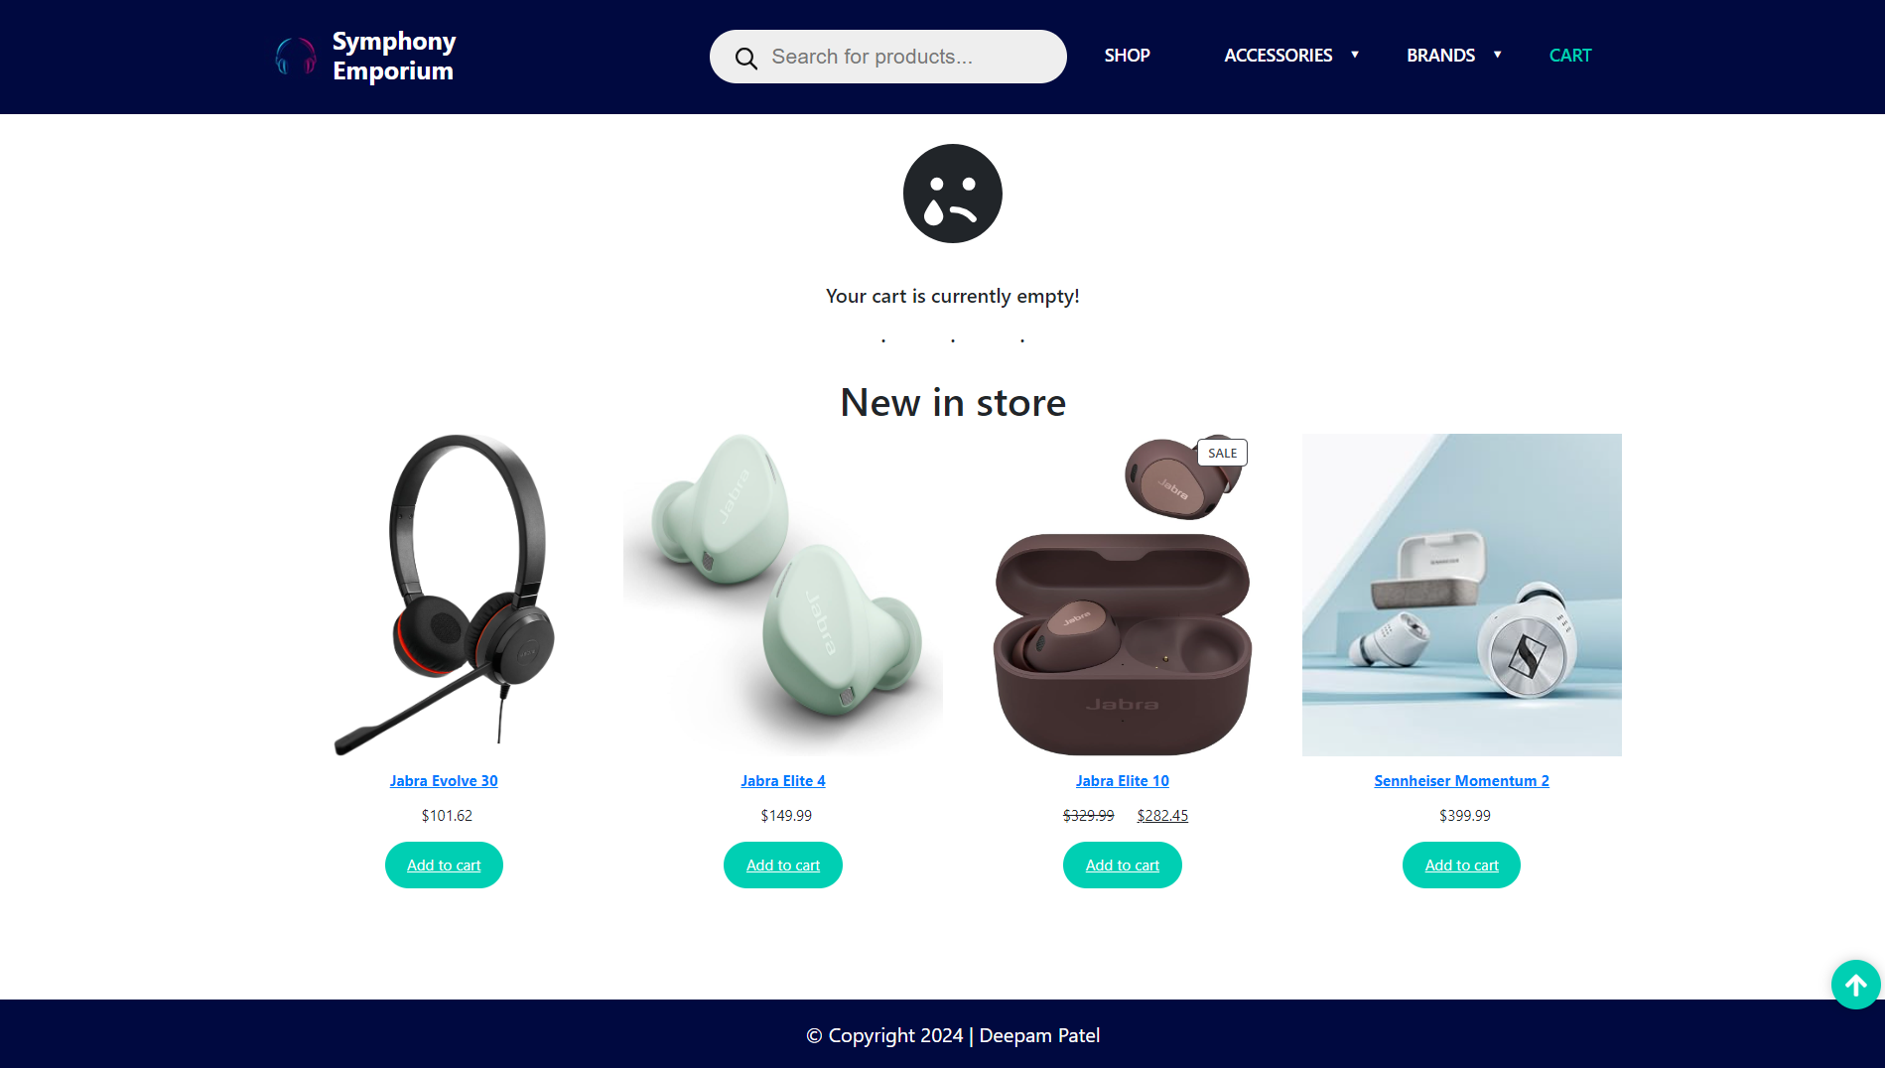

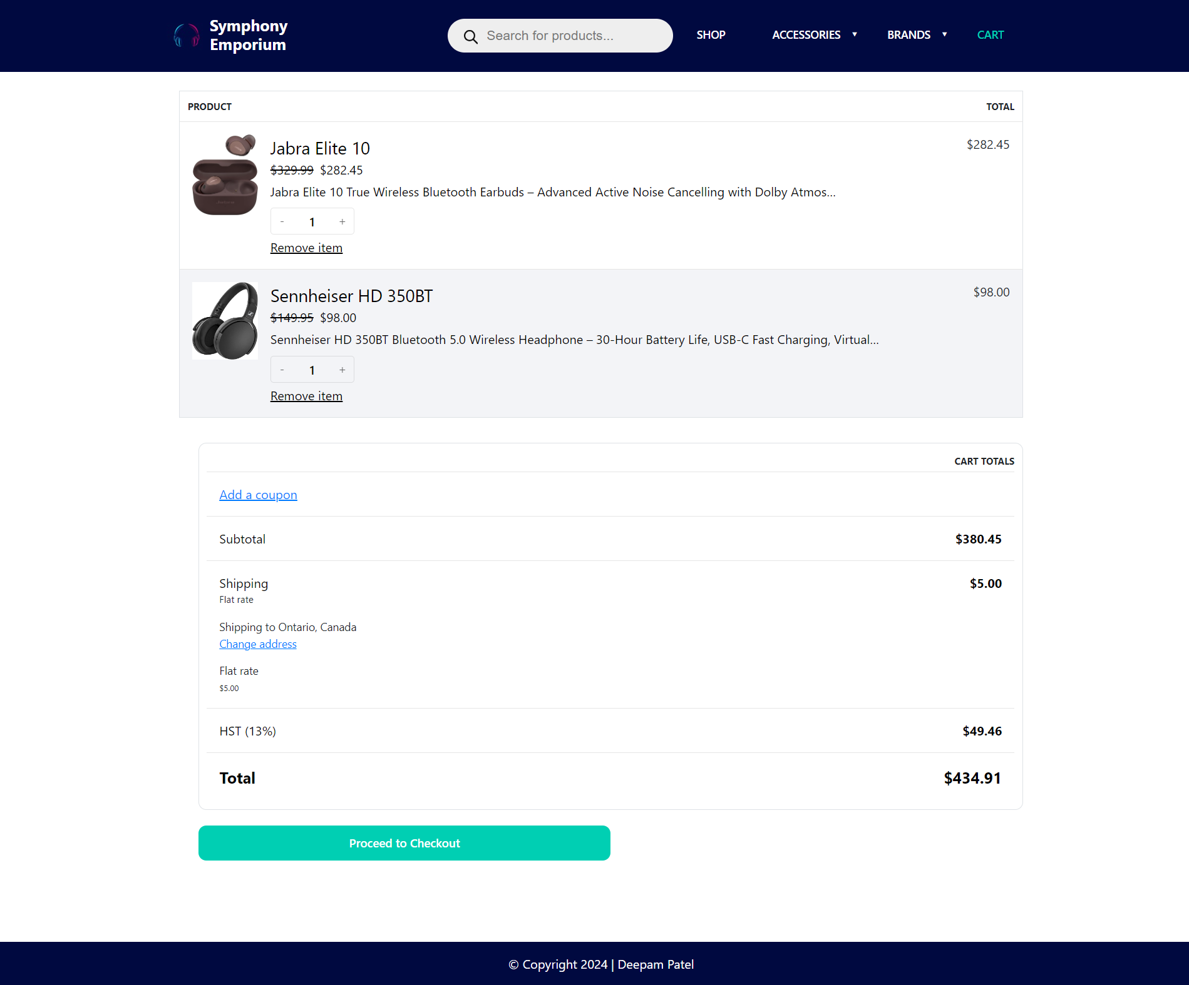

Checkout

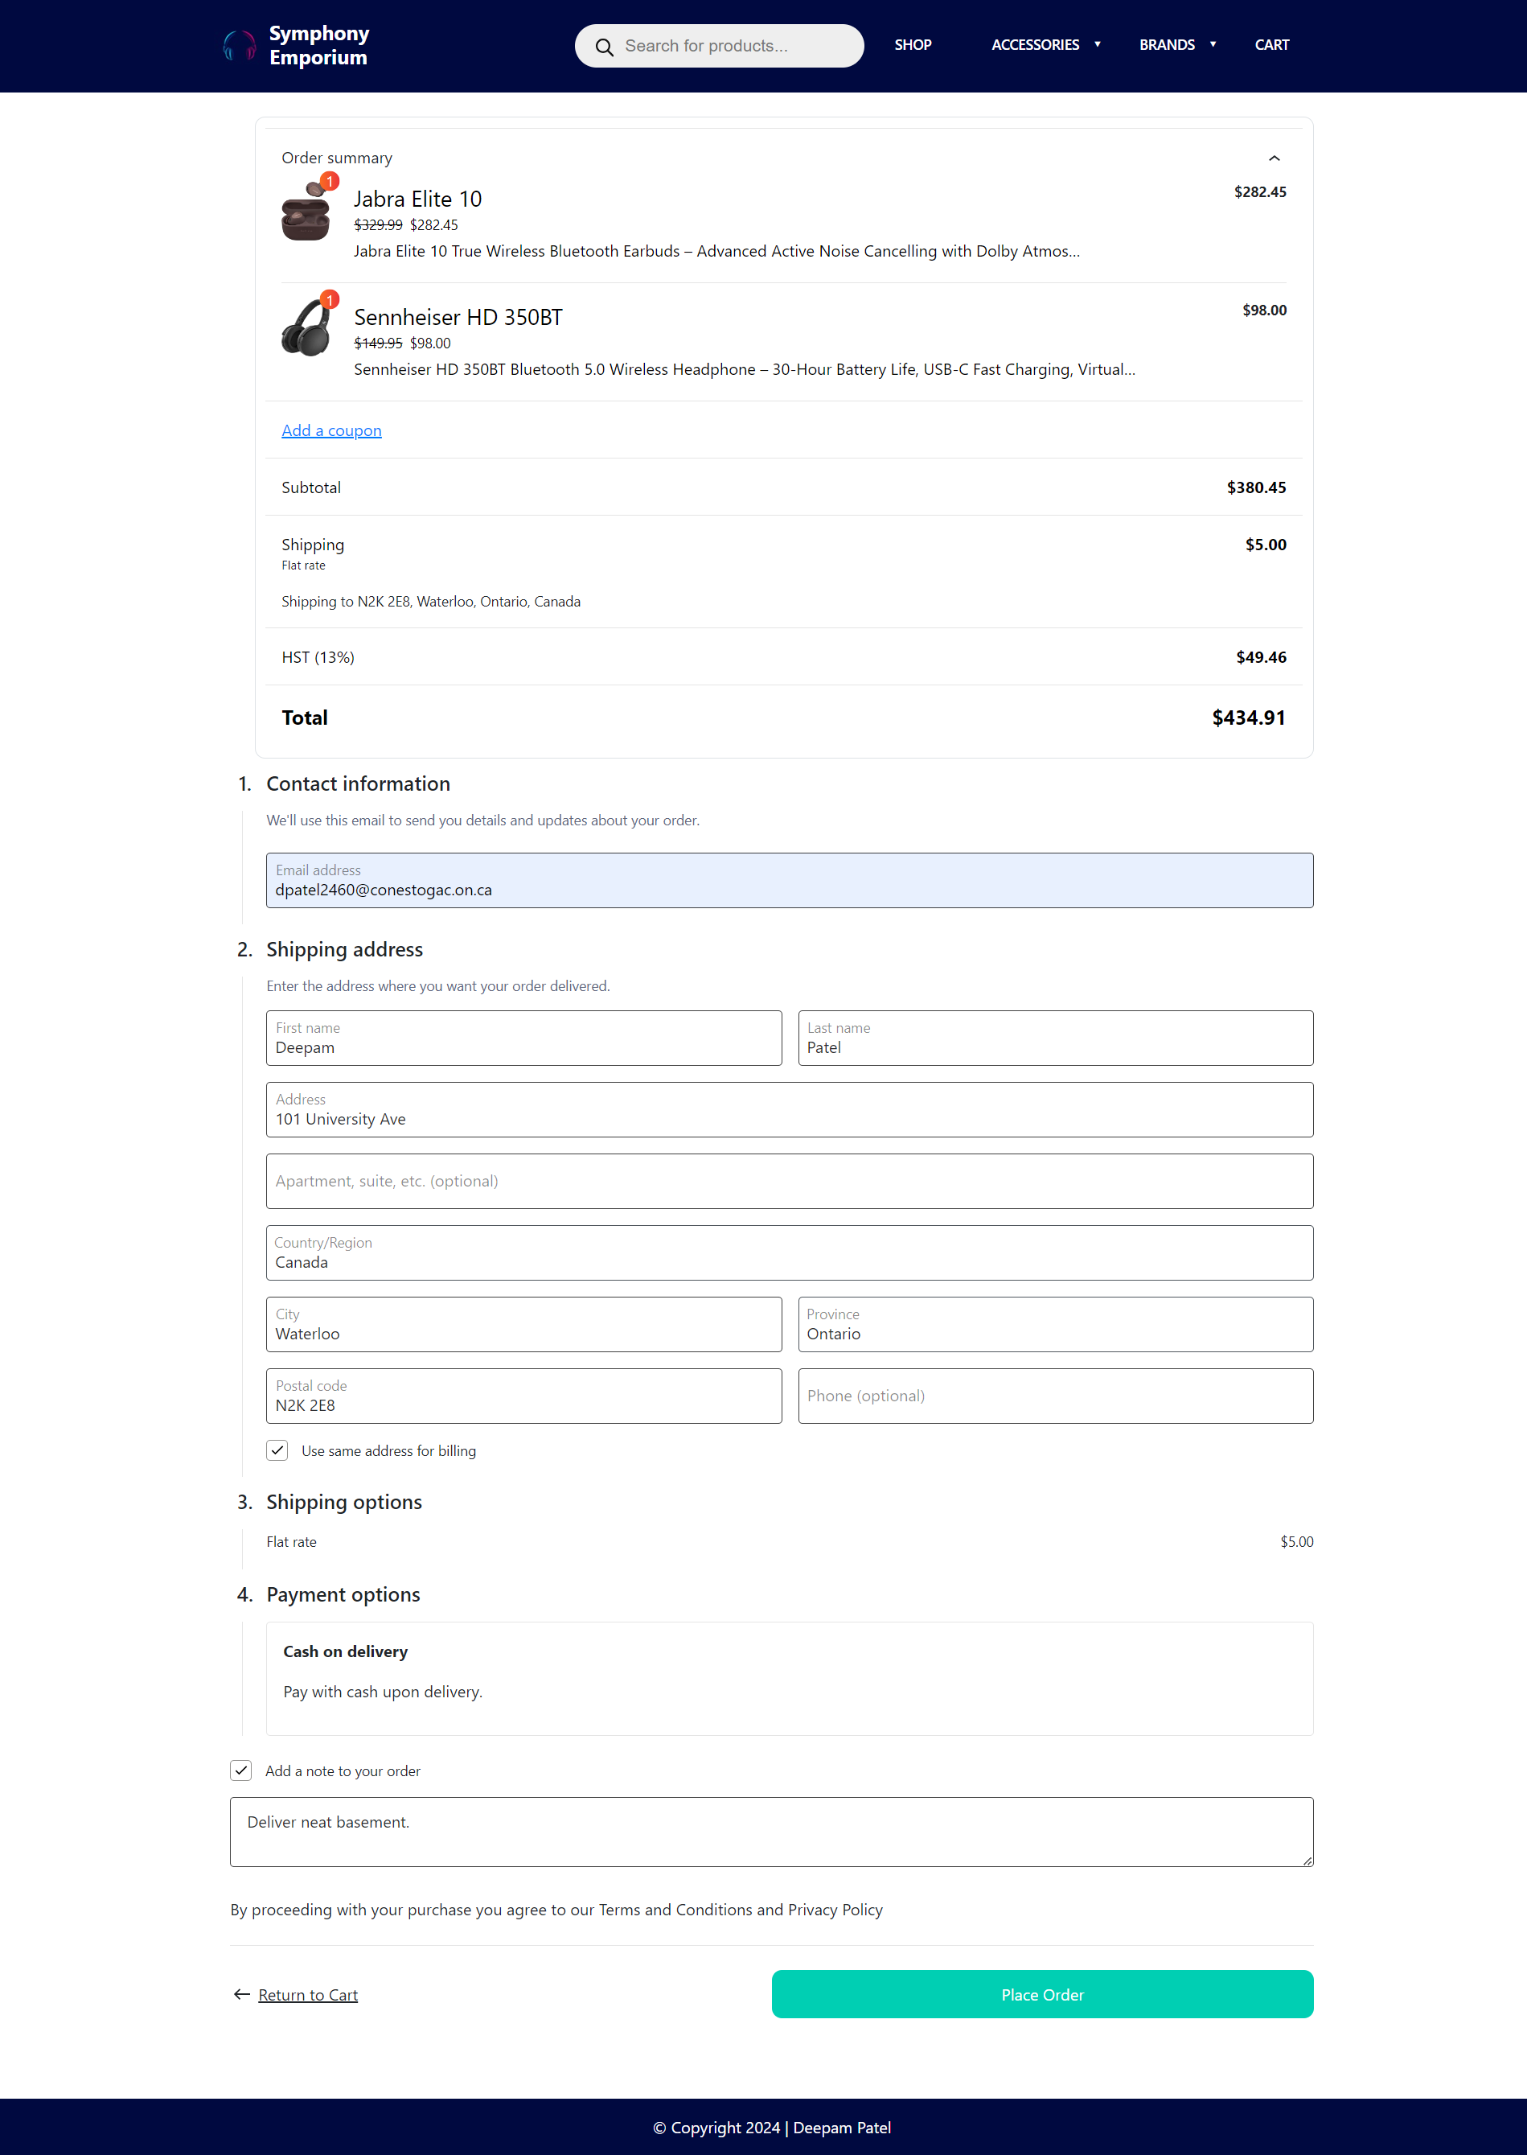

Order Details

